Danville Area High School
600 Walnut St., Danville, PA 17821
_____________________________________
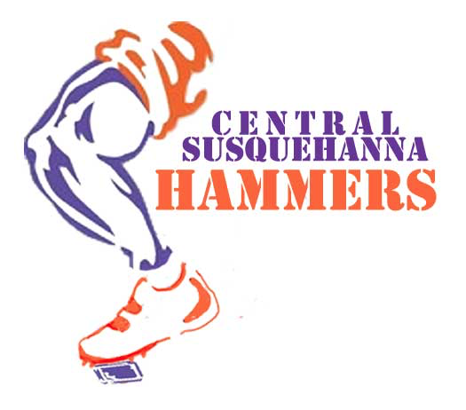
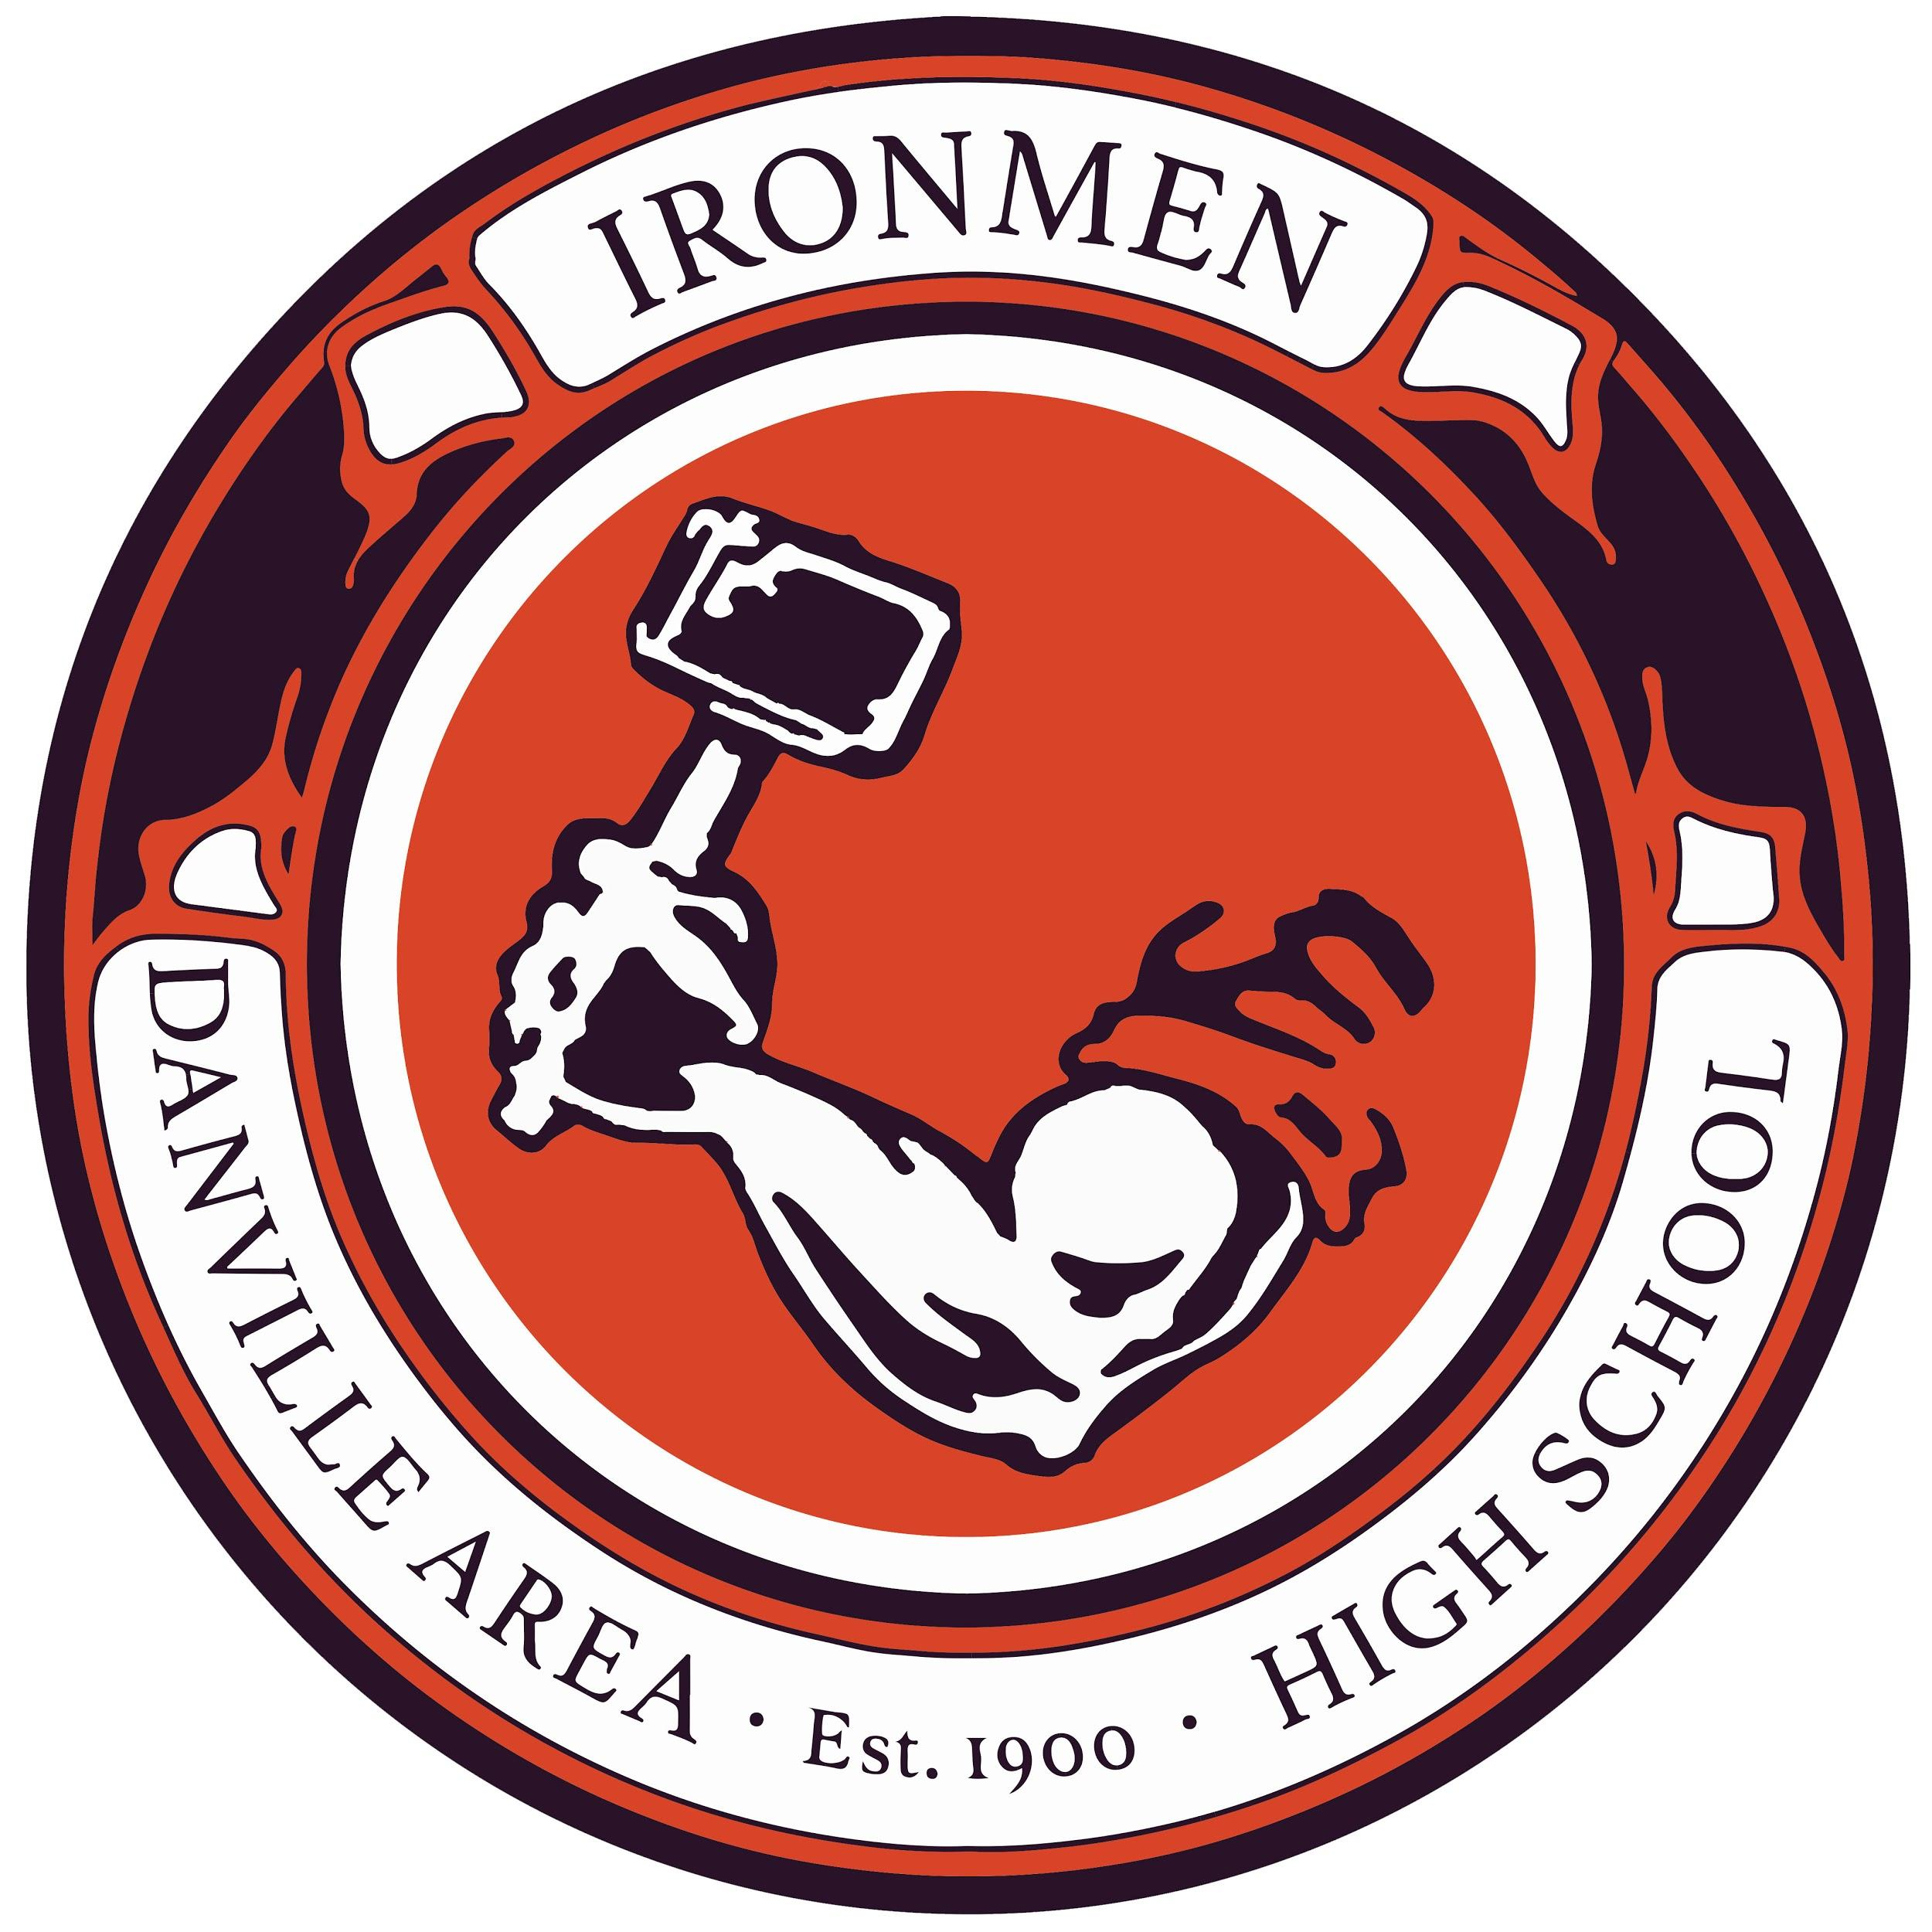

Central Susquehanna Hammers
Sponsorship request
May 11, 2017

To Whom It May Concern:

We are excited to introduce you to the Central Susquehanna Hammers Mountain Bike team. The team was started in 2017 as a club team in partnership with the Danville Area High School / Danville Area School District. The team will operate as a part of the Outdoor and Trails Club. Also included in the organizing partnership is the Montour Area Recreation Commission (MARC).

The team will be a part of a statewide organization, the Pennsylvania Interscholastic Cycling League (PICL). "Pickle" organized in 2016 and has doubled in size each year, since that beginning. Our goal is youth development that uses mountain biking to inspire healthy lifestyles, build strong communities, and teach respect for the environment.

Our club team is available to students grades 6th-12th grade. Members will learn mountain biking skills and gain fitness. Anyone who wishes to participate will be on the team; no one gets "cut" from the team. Members will be able to participate in the fall race series and compete against students from other schools in mountain bike races across the state.

In Central Pennsylvania we are particularly blessed with an abundance of exceptional trails well-suited for mountain biking at this age range. We aim to develop a love for the outdoors, improve fitness and build confidence in our students.

Currently we have six volunteer coaches and in our first year we had 15 students athletes. We expect more coaches and students to join this year. We officially start our season July 1st and end after the last race in late October.

Student athletes will be required to pay a fee to help offset our costs for this year. Despite the revenue generated from membership fees we expect to fall short of our funding needs for the season.

Attached our sample proposed budget for the season.
We are asking for sponsorship at whichever level your business is able.

Sponsors will have their logo placed on the team jersey and displayed at most practices and all races. All promotional displays including potential banners and tents will include sponsor logos.

Sponsorship opportunities include:

Gold sponsorship-$2000 or more.
Business logo or message (large) printed on the team jersey. Sponsor acknowledged in social media and local press when appropriate.

Silver sponsorship-$500 or more.
Business logo or message (medium) printed on the team jersey. Sponsor acknowledged in social media and local press when appropriate.

Bronze sponsorship - $100 or more.
Sponsor acknowledged in social media and local press when appropriate.

We will finalize our sponsors on July 1st. While your business may still be able to support our club after this date, we will not be able to guarantee your logo on printed promotional materials or team jerseys.

All monetary sponsorships/donations should be made out to Outdoor and Trails Club -- Danville Area School District. The district is a not-for-profit organization and our Tax ID number will be provided after your sponsorship has been processed.

Thank you in advance for your consideration.

Head Coaches,

David Decoteau Matt McElroy
Cell 570 854-2437 Cell 570 854-7898

